НАЦІОНАЛЬНИЙ ТЕХНІЧНИЙ УНІВЕРСИТЕТ
«ХАРКІВСЬКИЙ ПОЛІТЕХНІЧНИЙ ІНСТИТУТ»
Кафедра «ОБЧИСЛЮВАЛЬНОЇ ТЕХНІКИ ТА ПРОГРАМУВАННЯ»

«Комп'ютерна графіка»
Звiт з лабораторної роботи №9
Тема: «ПЕРЕТВОРЕННЯ НА ПЛОЩИНІ»

Виконав:
Студент групи КІТ-119а
Момот Р.Є.

Харків – 2021

Лабораторна робота №9
ПЕРЕТВОРЕННЯ НА ПЛОЩИНІ
Ціль: вивчити, як виконуються двомірні перетворення за допомогою однорідних координат і матриці перетворення 3x3. Написати і налагодити програму для 2D перетворень.
Індивідуальне завдання: Виконати види афінних перетворення фігурі за індивідуальним варіантом. При виконанні завдання передбачити відновлення початкової позиції фігури. Керування організувати як через інтерфейсні елементи (меню, кнопки, рядки редагування і ін.), так і через «гарячі» клавіші.

Результати роботи
Код програми
Файл Form1.cs
using System;
using System.Drawing;
using System.Windows.Forms;
using System.Drawing.Drawing2D;

namespace lab09
{
public partial class Form1 : Form
{
private int x = 0, y = -47; //начальные координаты фигуры
public Form1()
{
InitializeComponent();
this.BackColor = Color.White;
this.KeyPreview = true;
this.Text = "Lab 9. Momot Roman";

panel1.Paint += new PaintEventHandler(panel1Paint);
}
private void panel1Paint(object sender, PaintEventArgs e)
{
Graphics g = e.Graphics;
DrawAxis(g);
ApplyTransformation(g);
}
private void ApplyTransformation(Graphics g)
{
Matrix m = new Matrix(); // Новая матрица преобразования
m.Translate(panel1.Width / 2, panel1.Height / 2); // Определяем центр

// Перемещение
int dx = Convert.ToInt16(tbTranslationX.Text);
int dy = -Convert.ToInt16(tbTranslationY.Text);
m.Translate(dx, dy);

// Маштабирование
float sx = Convert.ToSingle(tbScaleX.Text);
m.Scale(sx, sx);

// Поворот
float angle = Convert.ToSingle(tbRotaionAngle.Text);
m.RotateAt(angle, new PointF(0, 0));

// Сдвиг
float alpha = Convert.ToSingle(tbShearX.Text);
float beta = Convert.ToSingle(tbShearY.Text);
m.Shear(alpha, beta);

g.Transform = m;
DrawFigure(g, Color.Black);
}
private void DrawFigure(Graphics g, Color color)
{
SolidBrush brush = new SolidBrush(color);
Point[] curvePoints = {
new Point(x, y),
new Point(x + 12, y + 37),
new Point(x + 52, y + 37),
new Point(x + 21, y + 59),
new Point(x + 32, y + 95),
new Point(x + 0, y + 75),
new Point(x - 32, y + 95),
new Point(x - 21, y + 59),
new Point(x - 51, y + 37),
new Point(x - 11, y + 37)
};

g.FillPolygon(brush, curvePoints);
}
private void DrawAxis(Graphics g)
{
Matrix m = new Matrix();

// определяем матрицу преобразований
m.Translate(panel1.Width / 2, panel1.Height / 2);

// Применяем матрицу преобразования к графическому объекту:
g.Transform = m;

// Рисуем оси x и y:
g.DrawLine(Pens.Blue, -panel1.Width / 2, 0,panel1.Width / 2, 0);
g.DrawLine(Pens.Blue, 0, -panel1.Height / 2,0, panel1.Height / 2);

// Добавляем метки к осям X и Y:
g.DrawString("X", this.Font, Brushes.Blue, panel1.Width / 2 - 20, -20);
g.DrawString("Y", this.Font, Brushes.Blue, 5, -panel1.Height / 2 + 5);
}
private void button1_Click_1(object sender, EventArgs e)
{
panel1.Invalidate();
}
private void button2_Click(object sender, EventArgs e)
{
//Сбрасываем параметры к исходным
tbTranslationX.Text = "0";
tbTranslationY.Text = "0";
tbScaleX.Text = "1";
tbRotaionAngle.Text = "0";
tbShearX.Text = "0";
tbShearY.Text = "0";

panelbm.Invalidate();
panel1.Invalidate();
}

private void button1_KeyDown(object sender, KeyEventArgs e)
{
{
button1.PerformClick();// имитируем нажатие button1
}
}
private void Form1_KeyDown(object sender, KeyEventArgs e)
{
if (e.KeyValue == (char)Keys.Right)
{
Matrix m = new Matrix();
m.Translate(panel1.Width / 2, panel1.Height / 2);

int dx = Convert.ToInt16(tbTranslationX.Text) + 1;
tbTranslationX.Text = dx.ToString();

int dy = -Convert.ToInt16(tbTranslationY.Text);
m.Translate(dx, dy);

panel1.Invalidate();
}
if (e.KeyValue == (char)Keys.Left)
{
Matrix m = new Matrix();
m.Translate(panel1.Width / 2, panel1.Height / 2);

int dx = Convert.ToInt16(tbTranslationX.Text) - 1;
tbTranslationX.Text = dx.ToString();

int dy = -Convert.ToInt16(tbTranslationY.Text);

m.Translate(dx, dy);
panel1.Invalidate();
}
if (e.KeyValue == (char)Keys.Up)
{
Matrix m = new Matrix();
m.Translate(panel1.Width / 2, panel1.Height / 2);

int dx = Convert.ToInt16(tbTranslationX.Text);
int dy = Convert.ToInt16(tbTranslationY.Text) + 1;
tbTranslationY.Text = dy.ToString();

m.Translate(dx, dy);
panel1.Invalidate();
}
if (e.KeyValue == (char)Keys.Down)
{
Matrix m = new Matrix();
m.Translate(panel1.Width / 2, panel1.Height / 2);

int dx = Convert.ToInt16(tbTranslationX.Text);
int dy = Convert.ToInt16(tbTranslationY.Text) - 1;
tbTranslationY.Text = dy.ToString();

m.Translate(dx, dy);
panel1.Invalidate();
}
if (e.KeyValue == (char)Keys.Up && e.KeyValue == (char)Keys.Left)
{
Matrix m = new Matrix();
m.Translate(panel1.Width / 2, panel1.Height / 2);

int dx = Convert.ToInt16(tbTranslationX.Text) - 1;
tbTranslationX.Text = dx.ToString();

int dy = Convert.ToInt16(tbTranslationY.Text) + 1;
tbTranslationY.Text = dy.ToString();

m.Translate(dx, dy);
panel1.Invalidate();
}
if (e.KeyValue == (char)Keys.Up && e.KeyValue == (char)Keys.Right)
{
Matrix m = new Matrix();
m.Translate(panel1.Width / 2, panel1.Height / 2);

int dx = Convert.ToInt16(tbTranslationX.Text) + 1;
tbTranslationX.Text = dx.ToString();

int dy = Convert.ToInt16(tbTranslationY.Text) + 1;
tbTranslationY.Text = dy.ToString();

m.Translate(dx, dy);
panel1.Invalidate();
}
if (e.KeyValue == (char)Keys.Down && e.KeyValue == (char)Keys.Right)
{
Matrix m = new Matrix();
m.Translate(panel1.Width / 2, panel1.Height / 2);

int dx = Convert.ToInt16(tbTranslationX.Text) + 1;
tbTranslationX.Text = dx.ToString();

int dy = Convert.ToInt16(tbTranslationY.Text) - 1;
tbTranslationY.Text = dy.ToString();

m.Translate(dx, dy);
panel1.Invalidate();
}
if (e.KeyValue == (char)Keys.Down && e.KeyValue == (char)Keys.Left)
{
Matrix m = new Matrix();
m.Translate(panel1.Width / 2, panel1.Height / 2);

int dx = Convert.ToInt16(tbTranslationX.Text) - 1;
tbTranslationX.Text = dx.ToString();

int dy = Convert.ToInt16(tbTranslationY.Text) - 1;
tbTranslationY.Text = dy.ToString();

m.Translate(dx, dy);
panel1.Invalidate();
}
if (e.KeyValue == (char)Keys.Q)
{
Matrix m = new Matrix();
m.Translate(panel1.Width / 2, panel1.Height / 2);

float angle = Convert.ToSingle(tbRotaionAngle.Text) - 1;
tbRotaionAngle.Text = angle.ToString();

m.RotateAt(angle, new PointF(0, 0));
}
if (e.KeyValue == (char)Keys.E)
{
Matrix m = new Matrix();
m.Translate(panel1.Width / 2, panel1.Height / 2);

float angle = Convert.ToSingle(tbRotaionAngle.Text) + 1;
tbRotaionAngle.Text = angle.ToString();

m.RotateAt(angle, new PointF(0, 0));
}
}
private void button2_KeyDown(object sender, KeyEventArgs e)
{
{
button2.PerformClick();// имитируем нажатие button2
}
}
private void тЫКToolStripMenuItem_Click(object sender, EventArgs e)
{
string message = "Q, E - Наклон фигуры\nСтрелки - Перемещение фигуры";
string title = "Помощь";
MessageBox.Show(message, title);
}

private void label3_Click(object sender, EventArgs e) { }
private void textBox1_TextChanged(object sender, EventArgs e) { }
private void textBox2_TextChanged(object sender, EventArgs e) { }
private void tbScaleX_TextChanged(object sender, EventArgs e) { }
}
}

Файл Form1.Designer.cs
namespace lab09
{
partial class Form1
{
/// <summary>
/// Обязательная переменная конструктора.
/// </summary>
private System.ComponentModel.IContainer components = null;

/// <summary>
/// Освободить все используемые ресурсы.
/// </summary>
/// <param name="disposing">истинно, если управляемый ресурс должен быть удален; иначе ложно.</param>
protected override void Dispose(bool disposing)
{
if (disposing && (components != null))
{
components.Dispose();
}
base.Dispose(disposing);
}

#region Код, автоматически созданный конструктором форм Windows

/// <summary>
/// Требуемый метод для поддержки конструктора — не изменяйте
/// содержимое этого метода с помощью редактора кода.
/// </summary>
private void InitializeComponent()
{
System.ComponentModel.ComponentResourceManager resources = new System.ComponentModel.ComponentResourceManager(typeof(Form1));
this.panel1 = new System.Windows.Forms.Panel();
this.button2 = new System.Windows.Forms.Button();
this.button1 = new System.Windows.Forms.Button();
this.label9 = new System.Windows.Forms.Label();
this.label8 = new System.Windows.Forms.Label();
this.label5 = new System.Windows.Forms.Label();
this.label2 = new System.Windows.Forms.Label();
this.label1 = new System.Windows.Forms.Label();
this.tbShearY = new System.Windows.Forms.TextBox();
this.panelbm = new System.Windows.Forms.Panel();
this.tbTranslationY = new System.Windows.Forms.TextBox();
this.tbTranslationX = new System.Windows.Forms.TextBox();
this.textBox4 = new System.Windows.Forms.TextBox();
this.textBox3 = new System.Windows.Forms.TextBox();
this.textBox2 = new System.Windows.Forms.TextBox();
this.textBox1 = new System.Windows.Forms.TextBox();
this.tbShearX = new System.Windows.Forms.TextBox();
this.tbRotaionAngle = new System.Windows.Forms.TextBox();
this.tbScaleX = new System.Windows.Forms.TextBox();
this.label3 = new System.Windows.Forms.Label();
this.menuStrip1 = new System.Windows.Forms.MenuStrip();
this.помощьToolStripMenuItem = new System.Windows.Forms.ToolStripMenuItem();
this.тЫКToolStripMenuItem = new System.Windows.Forms.ToolStripMenuItem();
this.panelbm.SuspendLayout();
this.menuStrip1.SuspendLayout();
this.SuspendLayout();
//
// panel1
//
this.panel1.BorderStyle = System.Windows.Forms.BorderStyle.FixedSingle;
this.panel1.Location = new System.Drawing.Point(147, 41);
this.panel1.Name = "panel1";
this.panel1.Size = new System.Drawing.Size(444, 483);
this.panel1.TabIndex = 24;
//
// button2
//
this.button2.Location = new System.Drawing.Point(19, 338);
this.button2.Name = "button2";
this.button2.Size = new System.Drawing.Size(100, 23);
this.button2.TabIndex = 23;
this.button2.Text = "Сброс";
this.button2.UseVisualStyleBackColor = true;
this.button2.Click += new System.EventHandler(this.button2_Click);
this.button2.KeyDown += new System.Windows.Forms.KeyEventHandler(this.button2_KeyDown);
//
// button1
//
this.button1.Cursor = System.Windows.Forms.Cursors.Hand;
this.button1.Location = new System.Drawing.Point(19, 309);
this.button1.Name = "button1";
this.button1.Size = new System.Drawing.Size(100, 23);
this.button1.TabIndex = 22;
this.button1.Text = "Результат";
this.button1.UseVisualStyleBackColor = true;
this.button1.Click += new System.EventHandler(this.button1_Click_1);
this.button1.KeyDown += new System.Windows.Forms.KeyEventHandler(this.button1_KeyDown);
//
// label9
//
this.label9.AutoSize = true;
this.label9.Font = new System.Drawing.Font("Microsoft Sans Serif", 11.25F, System.Drawing.FontStyle.Regular, System.Drawing.GraphicsUnit.Point, ((byte)(204)));
this.label9.Location = new System.Drawing.Point(27, 267);
this.label9.Name = "label9";
this.label9.Size = new System.Drawing.Size(17, 18);
this.label9.TabIndex = 21;
this.label9.Text = "Y";
//
// label8
//
this.label8.AutoSize = true;
this.label8.Font = new System.Drawing.Font("Microsoft Sans Serif", 11.25F, System.Drawing.FontStyle.Regular, System.Drawing.GraphicsUnit.Point, ((byte)(204)));
this.label8.Location = new System.Drawing.Point(26, 241);
this.label8.Name = "label8";
this.label8.Size = new System.Drawing.Size(18, 18);
this.label8.TabIndex = 20;
this.label8.Text = "X";
//
// label5
//
this.label5.AutoSize = true;
this.label5.Font = new System.Drawing.Font("Microsoft Sans Serif", 11.25F);
this.label5.Location = new System.Drawing.Point(16, 180);
this.label5.Name = "label5";
this.label5.Size = new System.Drawing.Size(42, 18);
this.label5.TabIndex = 17;
this.label5.Text = "Угол";
//
// label2
//
this.label2.AutoSize = true;
this.label2.Font = new System.Drawing.Font("Microsoft Sans Serif", 11.25F, System.Drawing.FontStyle.Regular, System.Drawing.GraphicsUnit.Point, ((byte)(204)));
this.label2.Location = new System.Drawing.Point(26, 57);
this.label2.Name = "label2";
this.label2.Size = new System.Drawing.Size(17, 18);
this.label2.TabIndex = 14;
this.label2.Text = "Y";
//
// label1
//
this.label1.AutoSize = true;
this.label1.Font = new System.Drawing.Font("Microsoft Sans Serif", 11.25F, System.Drawing.FontStyle.Regular, System.Drawing.GraphicsUnit.Point, ((byte)(204)));
this.label1.Location = new System.Drawing.Point(25, 34);
this.label1.Name = "label1";
this.label1.Size = new System.Drawing.Size(18, 18);
this.label1.TabIndex = 13;
this.label1.Text = "X";
//
// tbShearY
//
this.tbShearY.Location = new System.Drawing.Point(78, 267);
this.tbShearY.Name = "tbShearY";
this.tbShearY.Size = new System.Drawing.Size(50, 20);
this.tbShearY.TabIndex = 12;
this.tbShearY.Text = "0";
//
// panelbm
//
this.panelbm.BorderStyle = System.Windows.Forms.BorderStyle.Fixed3D;
this.panelbm.Controls.Add(this.button2);
this.panelbm.Controls.Add(this.tbShearX);
this.panelbm.Controls.Add(this.button1);
this.panelbm.Controls.Add(this.tbShearY);
this.panelbm.Controls.Add(this.tbRotaionAngle);
this.panelbm.Controls.Add(this.textBox4);
this.panelbm.Controls.Add(this.label8);
this.panelbm.Controls.Add(this.label3);
this.panelbm.Controls.Add(this.tbScaleX);
this.panelbm.Controls.Add(this.label9);
this.panelbm.Controls.Add(this.textBox2);
this.panelbm.Controls.Add(this.label5);
this.panelbm.Controls.Add(this.label2);
this.panelbm.Controls.Add(this.label1);
this.panelbm.Controls.Add(this.tbTranslationY);
this.panelbm.Controls.Add(this.textBox3);
this.panelbm.Controls.Add(this.tbTranslationX);
this.panelbm.Controls.Add(this.textBox1);
this.panelbm.Location = new System.Drawing.Point(5, 41);
this.panelbm.Name = "panelbm";
this.panelbm.Size = new System.Drawing.Size(136, 371);
this.panelbm.TabIndex = 26;
//
// tbTranslationY
//
this.tbTranslationY.Location = new System.Drawing.Point(78, 55);
this.tbTranslationY.Name = "tbTranslationY";
this.tbTranslationY.Size = new System.Drawing.Size(50, 20);
this.tbTranslationY.TabIndex = 5;
this.tbTranslationY.Text = "0";
//
// tbTranslationX
//
this.tbTranslationX.Location = new System.Drawing.Point(78, 31);
this.tbTranslationX.Name = "tbTranslationX";
this.tbTranslationX.Size = new System.Drawing.Size(50, 20);
this.tbTranslationX.TabIndex = 4;
this.tbTranslationX.Text = "0";
//
// textBox4
//
this.textBox4.Cursor = System.Windows.Forms.Cursors.Default;
this.textBox4.Location = new System.Drawing.Point(10, 215);
this.textBox4.Name = "textBox4";
this.textBox4.ReadOnly = true;
this.textBox4.Size = new System.Drawing.Size(118, 20);
this.textBox4.TabIndex = 30;
this.textBox4.Text = "Сдвиг";
this.textBox4.TextAlign = System.Windows.Forms.HorizontalAlignment.Center;
//
// textBox3
//
this.textBox3.Cursor = System.Windows.Forms.Cursors.Default;
this.textBox3.Location = new System.Drawing.Point(10, 152);
this.textBox3.Name = "textBox3";
this.textBox3.ReadOnly = true;
this.textBox3.Size = new System.Drawing.Size(118, 20);
this.textBox3.TabIndex = 29;
this.textBox3.Text = "Поворот";
this.textBox3.TextAlign = System.Windows.Forms.HorizontalAlignment.Center;
//
// textBox2
//
this.textBox2.Cursor = System.Windows.Forms.Cursors.Default;
this.textBox2.Location = new System.Drawing.Point(10, 90);
this.textBox2.Name = "textBox2";
this.textBox2.ReadOnly = true;
this.textBox2.Size = new System.Drawing.Size(118, 20);
this.textBox2.TabIndex = 28;
this.textBox2.Text = "Масштабирование";
this.textBox2.TextAlign = System.Windows.Forms.HorizontalAlignment.Center;
this.textBox2.TextChanged += new System.EventHandler(this.textBox2_TextChanged);
//
// textBox1
//
this.textBox1.Cursor = System.Windows.Forms.Cursors.Default;
this.textBox1.Location = new System.Drawing.Point(10, 5);
this.textBox1.Name = "textBox1";
this.textBox1.ReadOnly = true;
this.textBox1.Size = new System.Drawing.Size(118, 20);
this.textBox1.TabIndex = 27;
this.textBox1.Text = "Перемещение";
this.textBox1.TextAlign = System.Windows.Forms.HorizontalAlignment.Center;
this.textBox1.TextChanged += new System.EventHandler(this.textBox1_TextChanged);
//
// tbShearX
//
this.tbShearX.Location = new System.Drawing.Point(78, 241);
this.tbShearX.Name = "tbShearX";
this.tbShearX.Size = new System.Drawing.Size(50, 20);
this.tbShearX.TabIndex = 11;
this.tbShearX.Text = "0";
//
// tbRotaionAngle
//
this.tbRotaionAngle.Location = new System.Drawing.Point(78, 178);
this.tbRotaionAngle.Name = "tbRotaionAngle";
this.tbRotaionAngle.Size = new System.Drawing.Size(50, 20);
this.tbRotaionAngle.TabIndex = 8;
this.tbRotaionAngle.Text = "0";
//
// tbScaleX
//
this.tbScaleX.Location = new System.Drawing.Point(78, 116);
this.tbScaleX.Name = "tbScaleX";
this.tbScaleX.Size = new System.Drawing.Size(50, 20);
this.tbScaleX.TabIndex = 6;
this.tbScaleX.Text = "1";
this.tbScaleX.TextChanged += new System.EventHandler(this.tbScaleX_TextChanged);
//
// label3
//
this.label3.AutoSize = true;
this.label3.Font = new System.Drawing.Font("Microsoft Sans Serif", 11.25F, System.Drawing.FontStyle.Regular, System.Drawing.GraphicsUnit.Point, ((byte)(204)));
this.label3.Location = new System.Drawing.Point(7, 118);
this.label3.Name = "label3";
this.label3.Size = new System.Drawing.Size(65, 18);
this.label3.TabIndex = 29;
this.label3.Text = "Коэфф.";
this.label3.Click += new System.EventHandler(this.label3_Click);
//
// menuStrip1
//
this.menuStrip1.Items.AddRange(new System.Windows.Forms.ToolStripItem[] {
this.помощьToolStripMenuItem});
this.menuStrip1.Location = new System.Drawing.Point(0, 0);
this.menuStrip1.Name = "menuStrip1";
this.menuStrip1.Size = new System.Drawing.Size(606, 24);
this.menuStrip1.TabIndex = 27;
this.menuStrip1.Text = "menuStrip1";
//
// помощьToolStripMenuItem
//
this.помощьToolStripMenuItem.DropDownItems.AddRange(new System.Windows.Forms.ToolStripItem[] {
this.тЫКToolStripMenuItem});
this.помощьToolStripMenuItem.Name = "помощьToolStripMenuItem";
this.помощьToolStripMenuItem.Size = new System.Drawing.Size(68, 20);
this.помощьToolStripMenuItem.Text = "Помощь";
//
// тЫКToolStripMenuItem
//
this.тЫКToolStripMenuItem.Name = "тЫКToolStripMenuItem";
this.тЫКToolStripMenuItem.Size = new System.Drawing.Size(180, 22);
this.тЫКToolStripMenuItem.Text = "ТЫК";
this.тЫКToolStripMenuItem.Click += new System.EventHandler(this.тЫКToolStripMenuItem_Click);
//
// Form1
//
this.AutoScaleDimensions = new System.Drawing.SizeF(6F, 13F);
this.AutoScaleMode = System.Windows.Forms.AutoScaleMode.Font;
this.AutoSize = true;
this.ClientSize = new System.Drawing.Size(606, 535);
this.Controls.Add(this.panelbm);
this.Controls.Add(this.panel1);
this.Controls.Add(this.menuStrip1);
this.Icon = ((System.Drawing.Icon)(resources.GetObject("$this.Icon")));
this.KeyPreview = true;
this.MainMenuStrip = this.menuStrip1;
this.Name = "Form1";
this.Text = "Form1";
this.KeyDown += new System.Windows.Forms.KeyEventHandler(this.Form1_KeyDown);
this.panelbm.ResumeLayout(false);
this.panelbm.PerformLayout();
this.menuStrip1.ResumeLayout(false);
this.menuStrip1.PerformLayout();
this.ResumeLayout(false);
this.PerformLayout();

}

#endregion

private System.Windows.Forms.Panel panel1;
private System.Windows.Forms.Button button2;
private System.Windows.Forms.Button button1;
private System.Windows.Forms.Label label9;
private System.Windows.Forms.Label label8;
private System.Windows.Forms.Label label5;
private System.Windows.Forms.Label label2;
private System.Windows.Forms.Label label1;
private System.Windows.Forms.TextBox tbShearY;
private System.Windows.Forms.Panel panelbm;
private System.Windows.Forms.TextBox tbShearX;
private System.Windows.Forms.TextBox tbRotaionAngle;
private System.Windows.Forms.TextBox tbScaleX;
private System.Windows.Forms.TextBox tbTranslationY;
private System.Windows.Forms.TextBox tbTranslationX;
private System.Windows.Forms.TextBox textBox1;
private System.Windows.Forms.TextBox textBox2;
private System.Windows.Forms.TextBox textBox3;
private System.Windows.Forms.TextBox textBox4;
private System.Windows.Forms.Label label3;
private System.Windows.Forms.MenuStrip menuStrip1;
private System.Windows.Forms.ToolStripMenuItem помощьToolStripMenuItem;
private System.Windows.Forms.ToolStripMenuItem тЫКToolStripMenuItem;
}
}

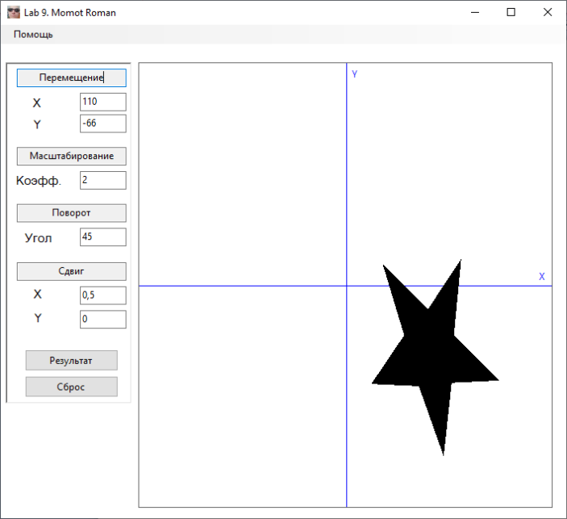
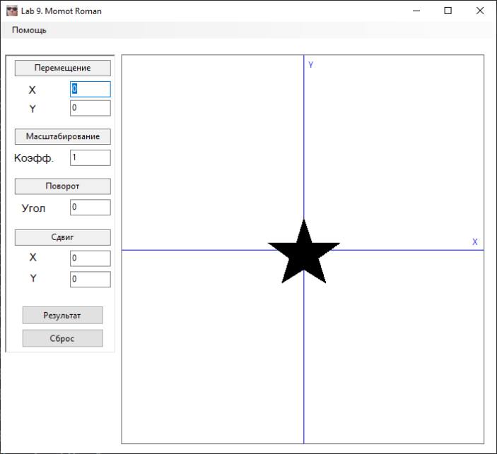
Результат роботи

Висновки
При виконанні даної лабораторної роботи було набуто навичок по перетворенню на площині.

